https://vms.isuzu.co.ke/passport/login
- Add Sign in with Microsoft Button
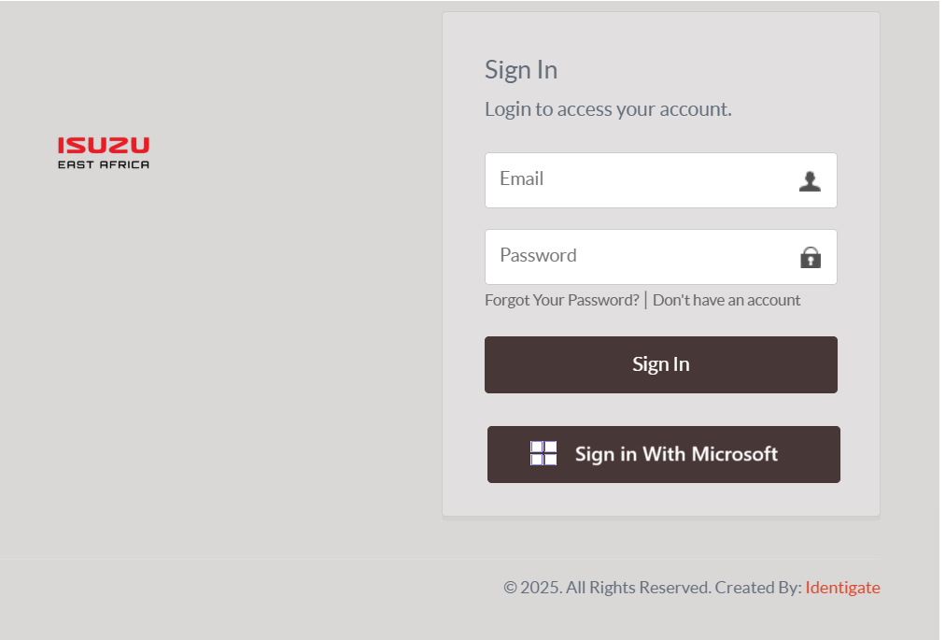
- Redirect user to Microsoft SSO Sign In page (user to enter Email and Password or appropriate sign in method.
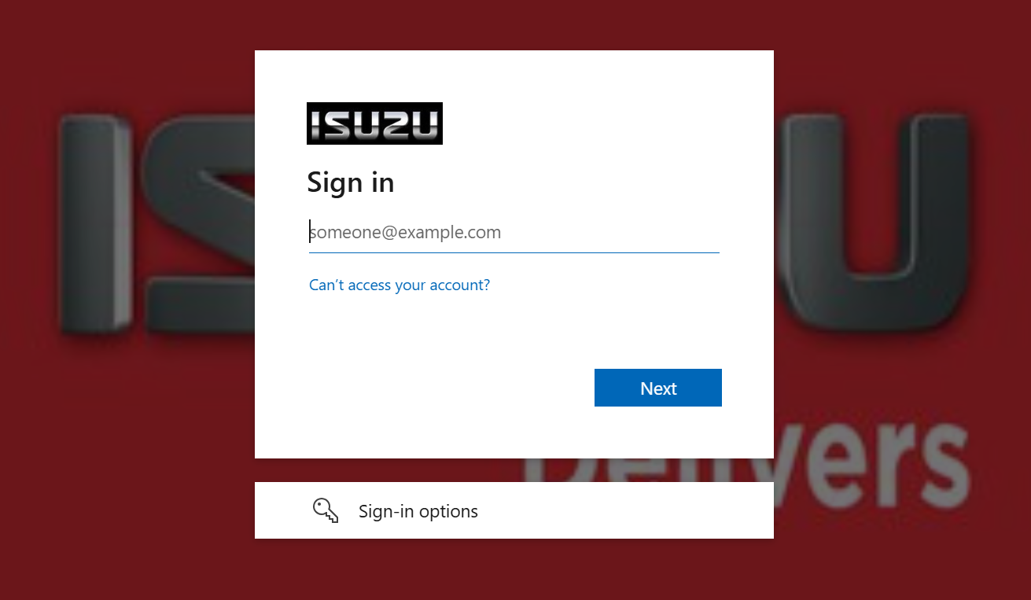
3 Allow user to update profile (Email address, Phone number etc (where possible get this data from SSO
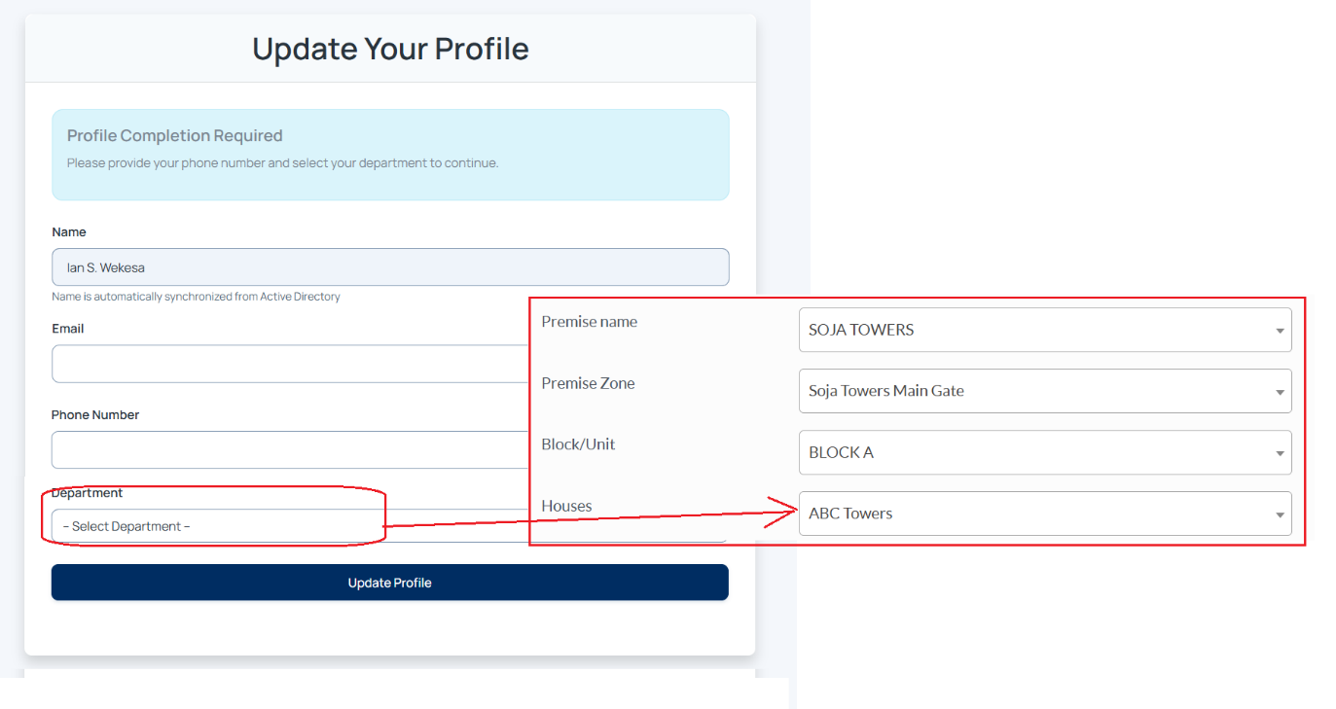
- Send an invitation email to Soja passport
